**Q1:**

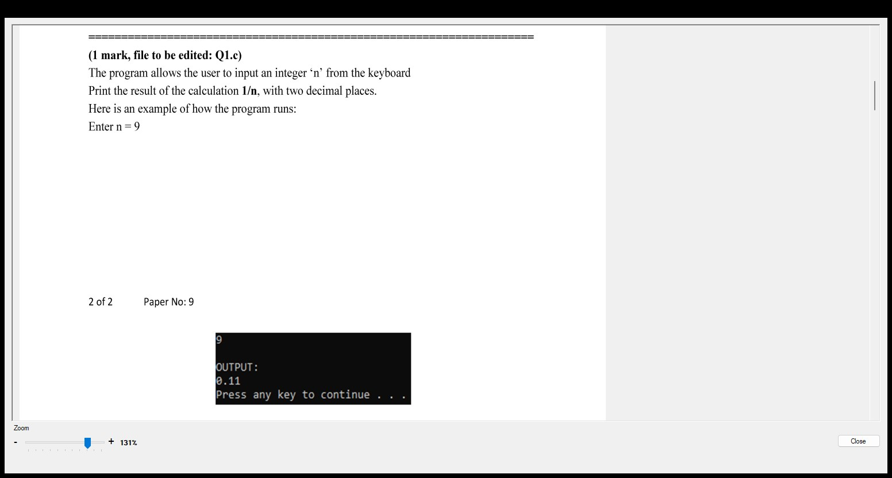

**#include <stdio.h>**

**int main() {**

**int n;**

**printf("Enter n = ");**

**scanf("%d", &n);**

**double result = 1.0 / n;**

**printf("%.2f\n", result);**

**return 0;**

**}**

**Q2:**

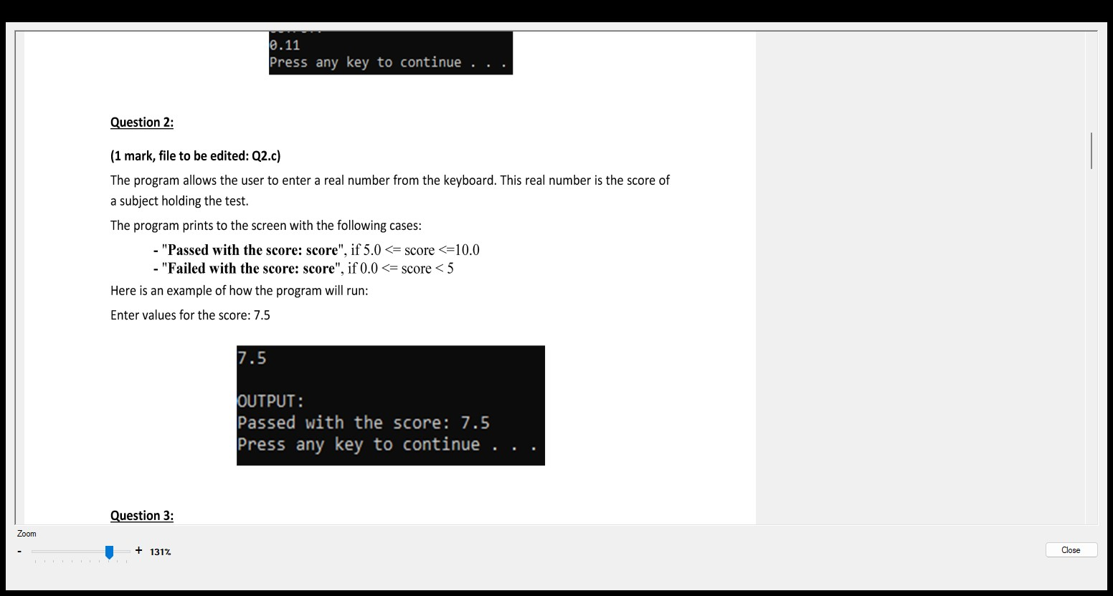

[**#include**](https://www.facebook.com/hashtag/include?__eep__=6&__tn__=R*F) <stdio.h>

int main() {

float score;

printf("Enter the score for the subject: ");

scanf("%f", &score);

if (score >= 5.0 && score <= 10.0) {

printf("Passed with the score: %.1f\n", score);

} else if (score >= 0.0 && score < 5.0) {

printf("Failed with the score: %.1f\n", score);

} else {

printf("Invalid score entered\n");

}

return 0;

}

**Q3:**

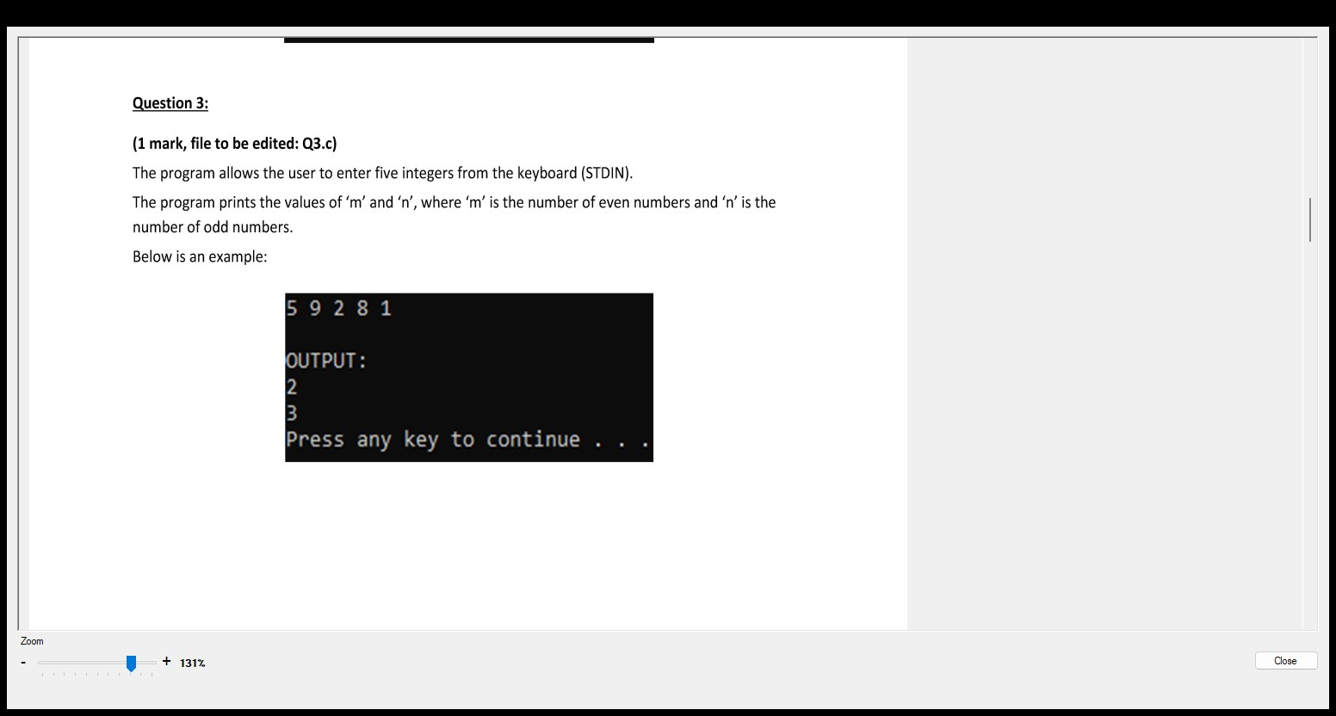

[**#include**](https://www.facebook.com/hashtag/include?__eep__=6&__tn__=R*F) <stdio.h>

int main() {

int arr[5];

printf("Enter five integers:\n");

for (int i = 0; i < 5; i++) {

scanf("%d", &arr[i]);

}

int m = 0, n = 0;

for (int i = 0; i < 5; i++) {

if (arr[i] % 2 == 0) {

m++;

} else {

n++;

}

}

printf("Number of even numbers: %d\n", m);

printf("Number of odd numbers: %d\n", n);

return 0;

}

**Q5:**

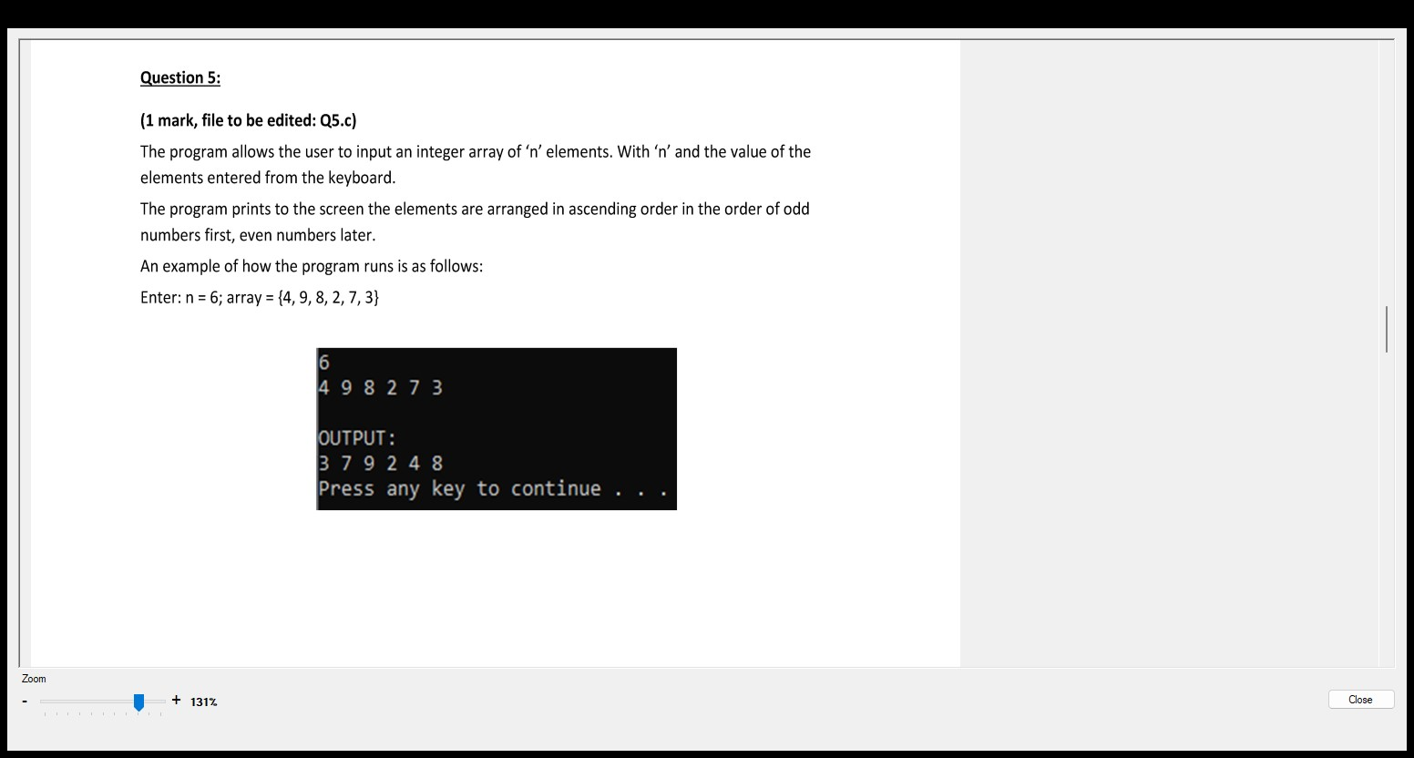

[**#include**](https://www.facebook.com/hashtag/include?__eep__=6&__tn__=R*F)<stdio.h>

void sort(int a[], int n){

int i, j;

for (i = 0; i < n - 1; i++) {

for (j = i + 1; j < n; j++) {

if (a[i] > a[j]) {

int temp = a[i];

a[i] = a[j];

a[j] = temp;

}

}

}

}

int main() {

int n, i;

scanf("%d", &n);

int a[n];

for (i = 0; i < n; i++) {

scanf("%d", &a[i]);

}

sort(a, n);

for (i = 0; i < n; i++) {

if (a[i] % 2 == 1) {

printf("%d ", a[i]);

}

}

for (i = 0; i < n; i++) {

if (a[i] % 2 == 0) {

printf("%d ", a[i]);

}

}

return 0;

}

**Q6:**

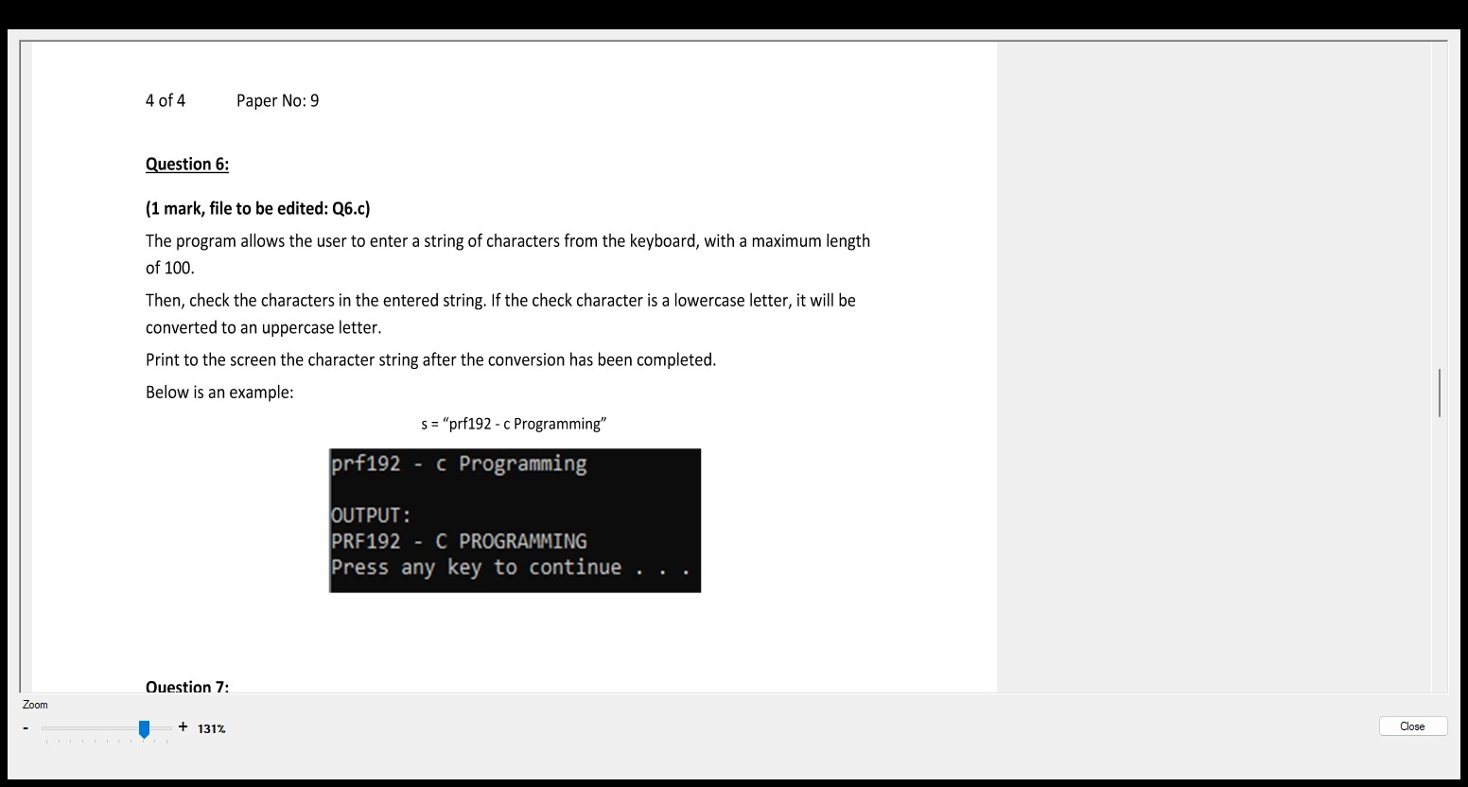

#include <stdio.h>

#include <string.h>

[**#include**](https://www.facebook.com/hashtag/include?__eep__=6&__tn__=R*F) <ctype.h>

int main() {

char str[100];

printf("Enter a string with a maximum length of 100 characters: ");

fgets(str, sizeof(str), stdin);

int len = strlen(str);

if (len > 0 && str[len-1] == '\n') {

str[--len] = '\0';

}

for (int i = 0; i < len; i++) {

if (islower(str[i])) {

str[i] = toupper(str[i]);

}

}

printf("The modified string is: %s\n", str);

return 0;

}

**Q7:**

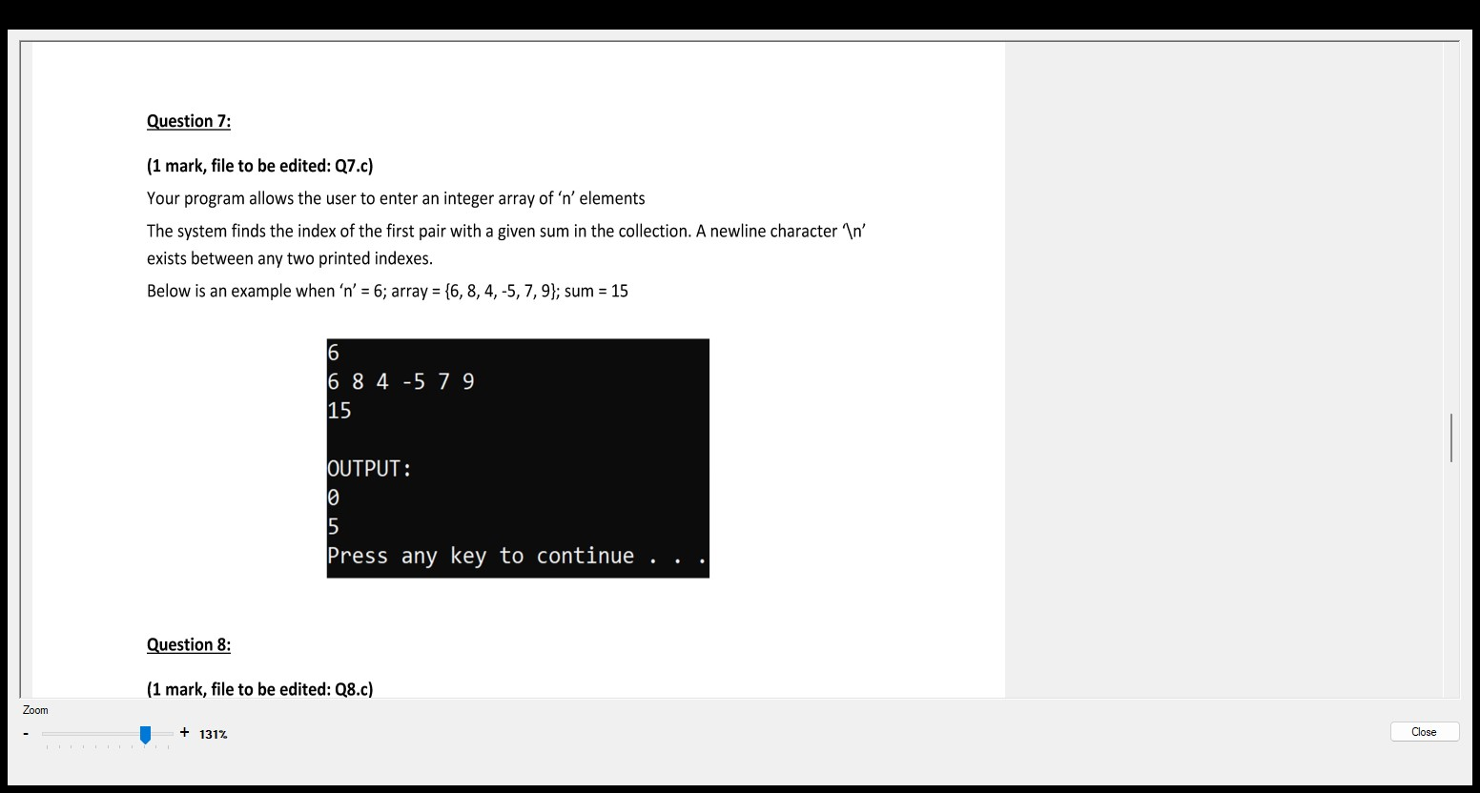

[**#include**](https://www.facebook.com/hashtag/include?__eep__=6&__tn__=R*F) <stdio.h>

int main() {

int n, sum;

printf("Enter the size of the array: ");

scanf("%d", &n);

int arr[n];

printf("Enter %d elements of the array:\n", n);

for (int i = 0; i < n; i++) {

scanf("%d", &arr[i]);

}

printf("Enter the sum to find: ");

scanf("%d", &sum);

for (int i = 0; i < n-1; i++) {

for (int j = i+1; j < n; j++) {

if (arr[i] + arr[j] == sum) {

printf("Indexes: %d %d\n", i, j);

return 0;

}

}

}

printf("No pair found with sum %d\n", sum);

return 0;

}

**Q8:**

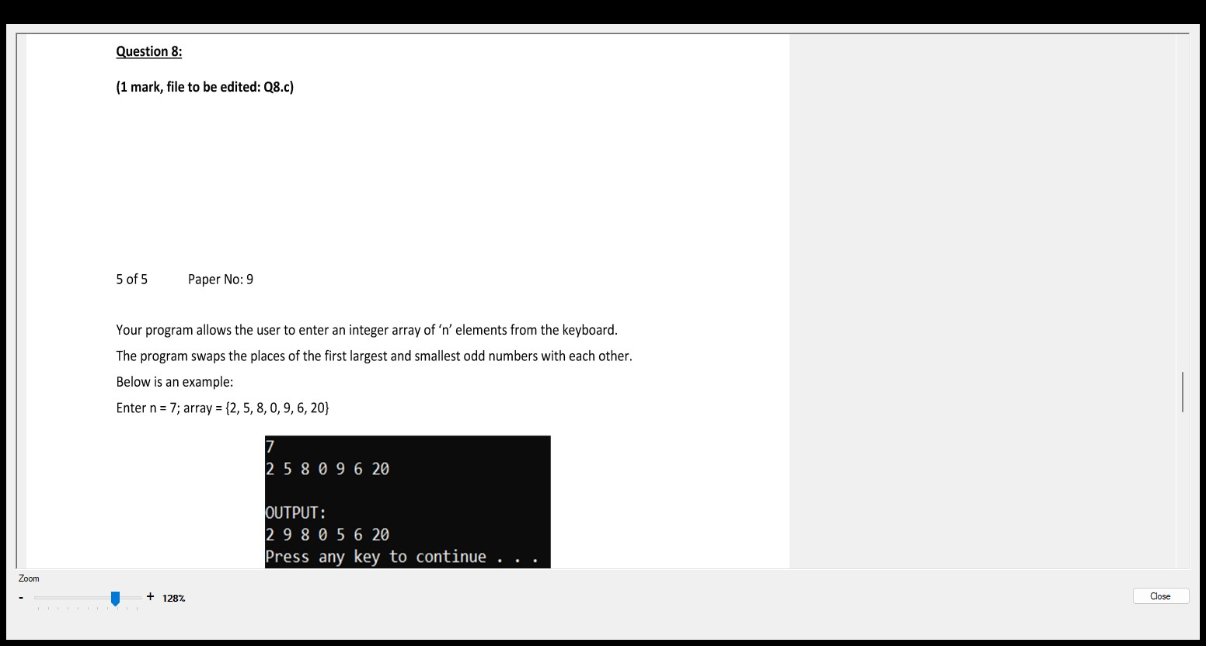

[**#include**](https://www.facebook.com/hashtag/include?__eep__=6&__tn__=R*F)<stdio.h>

void swap(int a[], int n, int pos_max, int pos_min){

int i, j;

for (i = 0; i < n - 1; i++) {

for (j = i + 1; j < n; j++) {

if (i == pos_min && j == pos_max || i == pos_max && j == pos_min) {

int temp = a[i];

a[i] = a[j];

a[j] = temp;

}

}

}

}

int main() {

int n, i;

scanf("%d", &n);

int a[n];

int max_odd = -1e9, min_odd = 1e9;

int pos_max, pos_min;

for (i = 0; i < n; i++) {

scanf("%d", &a[i]);

}

for (i = 0; i < n; i++) {

if (a[i] % 2 == 1 && a[i] > max_odd){

max_odd = a[i];

pos_max = i;

}

if (a[i] % 2 == 1 && a[i] < min_odd){

min_odd = a[i];

pos_min = i;

}

}

swap(a, n, pos_max, pos_min);

for (i = 0; i < n; i++) {

printf("%d ", a[i]);

}

return 0;

}

**Q9:**

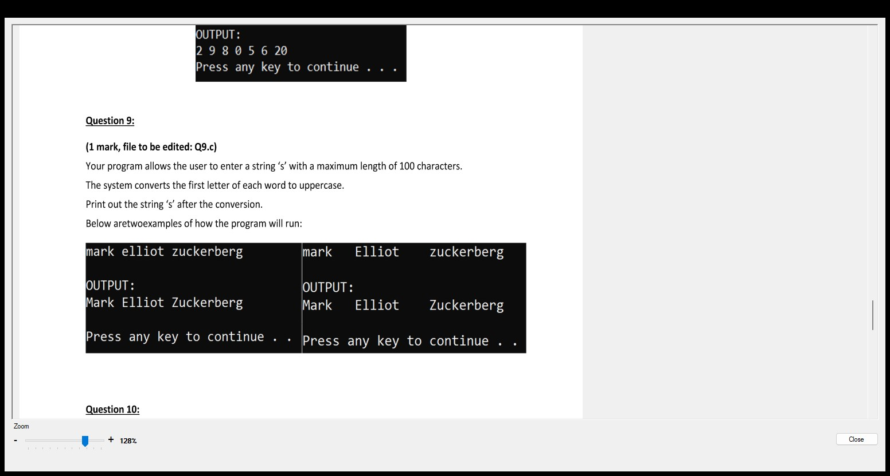

#include<stdio.h>

#include<string.h>

[**#include**](https://www.facebook.com/hashtag/include?__eep__=6&__tn__=R*F)<ctype.h>

int main(){

char s[100];

gets(s);

int i;

s[0] = toupper(s[0]);

for (i = 1; i < strlen(s); i++){

if (s[i - 1] == ' '){

s[i] = toupper(s[i]);

}

}

puts(s);

}

**Q10:**

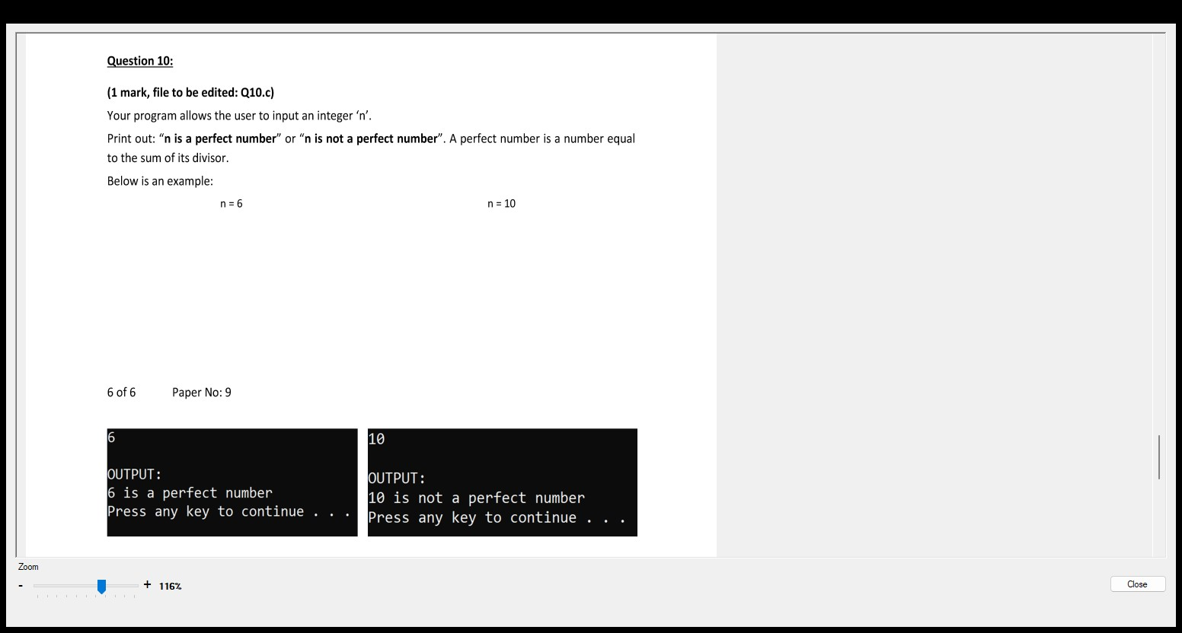

[**#include**](https://www.facebook.com/hashtag/include?__eep__=6&__tn__=R*F) <stdio.h>

int main() {

int n, sum = 0;

printf("Enter an integer: ");

scanf("%d", &n);

for (int i = 1; i <= n/2; i++) {

if (n % i == 0) {

sum += i;

}

}

if (sum == n) {

printf("%d is a perfect number\n", n);

} else {

printf("%d is not a perfect number\n", n);

}

return 0;

}